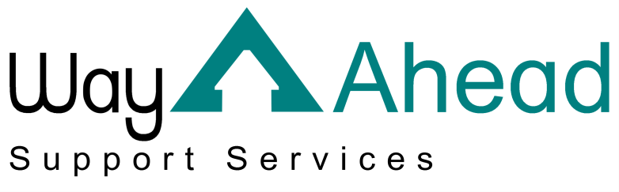
…Award winning service offering support the way you want it.

This is Way Ahead Support Services’ Privacy Notice.
As part of the services we offer, we are required to process personal data about our staff, our service users and, in some instances, the friends or relatives of our service users and staff. “Processing” can mean collecting, recording, organising, storing, sharing or destroying data.
We are committed to being transparent about why we need your personal data and what we do with it. This information is set out in this privacy notice. It also explains your rights when it comes to your data.
If you have any concerns or questions please contact us via: email: info@wayaheaduk.org telephone: 01926 622980 or post: Way Ahead Support Services, 4 Jephson Court, Tancred Close, Leamington Spa, Warwickshire, CV31 3RZ.

Staff

What data do we have?
So that we can provide a safe and professional service, we need to keep certain records about you. We may record the following types of data:
- Your basic details and contact information e.g. your name, address, date of birth, National Insurance number and next of kin;
- Your financial details e.g. details so that we can pay you, insurance, pension and tax details;
- Your training records.

We also record the following data which is classified as “special category”:
- Health and social care data about you, which might include both your physical and mental health data – we will only collect this if it is necessary for us to know as your employer, e.g. fit notes or in order for you to claim statutory maternity/paternity pay;
- We may also, with your permission, record data about your race, ethnic origin, sexual orientation or religion.

As part of your application you may – depending on your job role – be required to undergo a Disclosure and Barring Service (DBS) check (Criminal Record Check). We do not keep this data once we’ve seen it.

Why do we have this data?
We require this data so that we can contact you, pay you and make sure you receive the training and support you need to perform your job. By law, we need to have a lawful basis for processing your personal data.
We process your data because:
- We have a legal obligation under UK employment law;
- We are required to do so in our performance of a public task;
- We have a legitimate interest in processing your data – for example, we provide data about your training to Skills for Care’s National Minimum Data Set, this allows Skills for Care to produce reports about workforce planning.
- We are required to provide data to our regulator, the Care Quality Commission (CQC), as part of our public interest obligations.

We process your special category data because:
- It is necessary for us to process requests for sick pay or maternity pay.

If we request your criminal records data it is because we have a legal obligation to do this due to the type of work you do. This is set out in the Data Protection Act 2018 and the Rehabilitation of Offenders Act 1974 (Exceptions) Order 1975. We do not keep a record of your criminal records information (if any).
We may also process your data with your consent. If we need to ask for your permission, we will offer you a clear choice and ask that you confirm to us that you consent. We will also explain clearly to you what we need the data for and how you can withdraw your consent.

Where do we process your data?
As your employer we need specific data. This is collected from or shared with:
- You or your legal representative(s);
- Third parties.
We may do this face to face, via phone, via email, via our website, via post, via application forms or via apps.
Third parties are organisations we have a legal reason to share your data with. These include:
- Her Majesty’s Revenue and Customs (HMRC);
- Our pension and healthcare schemes.
- Our external payroll provider.
- Our external employment law support provider.
- Organisations we have a legal obligation to share information with i.e. for safeguarding, the CQC;
- The police or other law enforcement agencies if we have to by law or court order.
- The DBS Service.

Your rights
The data that we keep about you is your data and we ensure that we keep it confidential and that it is used appropriately. You have the following rights when it comes to your data:
- You have the right to request a copy of all of the data we keep about you. Generally, we will not charge for this service;
- You have the right to ask us to correct any data we have which you believe to be inaccurate or incomplete. You can also request that we restrict all processing of your data while we consider your rectification request;
- You have the right to ask that we erase any of your personal data which is no longer necessary for the purpose we originally collected it for. We retain our data in line with the Information Governance Alliance’s guidelines (https://digital.nhs.uk/data-and-information/looking-after-information/data-security-and-information-governance/codes-of-practice-for-handling-information-in-health-and-care/records-management-code-of-practice-for-health-and-social-care-2016)
- You may also request that we restrict processing if we no longer require your personal data for the purpose we originally collected it for, but you do not wish for it to be erased.
- You can ask for your data to be erased if we have asked for your consent to process your data. You can withdraw consent at any time – please contact us to do so.
- If we are processing your data as part of our legitimate interests as an organisation or in order to complete a task in the public interest, you have the right to object to that processing. We will restrict all processing of this data while we look into your objection.
You may need to provide adequate information for our staff to be able to identify you, for example, a passport or driver’s licence. This is to make sure that data is not shared with the wrong person inappropriately. We will always respond to your request as soon as possible and at the latest within one month.
If you would like to complain about how we have dealt with your request, please contact:
Information Commissioner’s Office
Wycliffe House
Water Lane
Wilmslow
Cheshire
SK9 5AF
https://ico.org.uk/global/contact-us/

